Ministry of Finance
Iraq Insurance Company
Planning Dept.

Iraq Insurance Company
Annual Report for 2019

Prepared by Planning Dept.
Translated by Technical Dept.

Introduction

We put in your hands the annual report of the Iraqi Insurance Company according to the financial statements of the final accounts as on December 31, 2019.
It includes detailed data on the company's main activities (financial, productive, administrative and technical), as these data is the main pillar of the company's business activity. The company has achieved great results through which it was able to maintain its leading position in the Iraqi insurance market despite all the challenges and intense competition with other insurance companies.
The Iraqi Insurance Company is constantly seeking to develop its activities through developing the insurance portfolios, the appropriate and successful investment of resources, and spreading the insurance awareness among members of society which achieve growth of marketed insurance policies and the revenues generated from them.
These results have achieved from the concerted efforts of all employees, in this regard, we present our sincere thanks and gratitude to all our customers and our esteemed clients for their permanent confidence in our products, especially the departments of banks and governmental and private companies for their cooperation that indicates mutual trust for the purpose of developing insurance activity in a manner that guarantees the public interest. We also thank all of our company’s employees for their untiring performance of business, in a way that achieves the company's goals in order to continue developing its business and success and preserving its position.
Allah is the Grantor of success...

Abstract

- The nominal and paid up capital of the company is IQD two billion by Insurance Regulatory Act No. (10) of 2005. It is obtained the approval of the Ministry of Finance / Accounting Department / Committee for Determining Funds Capital to increase the company's capital to IQD 7500000000 (seven billion five hundred million dinars) and awaiting the approval of the General Secretariat of the Council of Ministers.
- The company comprises of 16 departments and it has 19 branches distributed in Iraq between Baghdad and other provinces, 6 in Baghdad and 13 in the provinces.
- The premiums earned in 2019 are IQD 71339000000/- which constitutes an increase of 15% over the planned premiums and a decrease of 12% compared with the premiums achieved in 2018.
- The company pays IQD 37031000000/- as claims for 6887 customer of different types of insurance which constitutes 107% of the expected claims of 2019 and exceeds the claims paid of 2018 by 8%.
- The company deals with different types of insurance: (Individual Life Ins., Group Ins., Health ins., Motor Ins., Marine – Cargo Ins., Fire and Accidents Ins., Engineering Ins. and Civil Liability Ins.).
- The company has 380 employees distributed between 192 administrative and 188 technicians including 196 males and 184 females, noting that the number of employees in the previous year was 398 employees, a decrease of 5% from last year.
- The invested amounts volume reached toIQD63101000000/- in 2019down by 5% of the planned amounts and up by 16% of the achieved amount in 2018%.
- The company was able to increase the return on investment by 11% over the previous year, reaching IQD 3320000000/-, with an implementation rate of 111%.
- The solvency of the company is 255% which indicates the progress and improvement of the company.
- The company achieves a net profit of 9946000000/- which represents an increase of 27% over the planned and an increase of 12% over the previous year.
- We would like to show the reason behind the discrepancy between the achieved and the planned premiums of the motor portfolio, due to non-renewal of the motor loan policies for 2019. As for the marine / goods portfolio, the reason is the fact that most of the imported goods are insured by the insurance companies in the origin country of the imported goods.
- The lawsuits which are filed against our company during 2019 are 18. (12) cases are settled, and (6) are still before the court.
- The company achieves profitability through its internal and external sources represented by insurance revenues amounting to IQD 72364516000/- and investment revenues of IQD 3320460000/-. The factors affecting the profits are the instability of the Iraqi economy.
- The extraordinary profits for 2019 amounted to 5760000/-, these profits include only incidental revenues.

Achievements and activities for 2019

- Contributing to developing the insurance market in Iraq and spreading insurance awareness and culture by holding a seminar at the Ministry of Finance.
- Issuing the Insurance Echo magazine specialized in the field of insurance business.
- An electronic archiving contract was signed with the Ministry of Industry / the General Company for Electronic Systems to archive the files of the company's employees.
- Training the company's employees and developing their skills by holding a training course at the company's headquarter in the field of insurance business
- An amount of one billion dinars has been underwritten to the Deposit Guarantee Company.

Problems and Obstacles

- Poor awareness and insurance culture among the citizens leads to the reluctance of many customers to obtain different insurance policies.
- The lack of loans granted to companies and citizens to activate business has negatively reflected on the insurance business.

Annual Report / 2019

Firstly: General Information

- Profile & History:
The Iraq Insurance Company established on 14/10/1959 according to Commercial Companies Act No. 31 of 1957 in Baghdad as a private company dealing with all types of insurance and reinsurance, in 1964 the company was nationalized by the companies nationalization resolutions specializing in life insurance only, and all the portfolios of foreign and Arabian companies in the Iraqi market at that time quoted to the company portfolio. The resolution No. 392 of 1988, allowed the company again to practice all types of insurance. Public Companies Act of 1997 opened a wide range of development and competition to the company. Insurance Regulatory Act No. 10 of 2005 organized the company activities. The company aims to develop the national economics through spreading the privileges of insurance among people.

- The Capital:
The nominal and paid up capital is two billion Dinar. In addition to the total assets which are more than (85) billion Dinar. According to the instructions No. 15 of 2012 regarding the minimum limit of the capital which is published in Iraqi Gazette number No. 4239 on 21/5/2012, it is obtained the approval of the Ministry of Finance / Accounting Department / Committee for Determining Funds Capital to increase the company's capital to IQD 7500000000/- and awaiting the approval of the General Secretariat of the Council of Ministers.

- Organizational Structure

The internal system consists of the organizational structure of Iraqi Insurance Company:

- Board of Directors:

According to State Companies Law No. 22 of 1997, consists of each of the following:-
Members | Name
Deputy Chairman | Haifaa Shamoun Essa
Experienced  & Competent  Member | Saeed Abbas Mirza
Experienced  & Competent  Member | Kareem YunisKadhum
Member | AnghamRahiAbdulwahid
Member | ShathaAbdelhadiHashim
Member | Nesreen Abdulmajeed Abdulazeez
Member | Majida Sada Hussein
Member | Faiza Salman Ibrahim
Member | Firyal Salim Abbas

- According to the administrative order 870 No. 5234 on 24/10/2019 and ministerial order 4408 No. 51292 on 25/11/2019, Mrs. Faiza Salman Ibrahim (financial Dept. Manager) is authorized to occupy the position of director general in Iraqi Insurance Company.

- Departments of the Co.:

The headquarter consists of the following departments:-

Manager Name | Department
Wafaa Hussein Mhamad | Administrative Dept.
Faiza Salman Ibrahim | Financial Dept.
Kadhum Shaker Mahmood | Internal Auditing Dept.
Bashar Sameer Fuaad | Planning Dept.
Mareewan Khaled Ali | Marketing Dept.
Ibtisam Abdulabbas Mhamad | I.T. Dept.
NesreenAbdulmajeedAbdulazeez | Technical Dept.
AnghamRahiAbdulwahid | Legal Dept.
Odaya Abdulmalik Mhamad | Investment Dept.
LamyaaFadilWuhaib | Life Insurance ( underwriting ) Dept.
ShathaAbdulhadiHashim | Life Insurance ( claims ) Dept.
Majida Sada Hussein | Motor Dept.
Ameera Mousa Abd | Fire and Accidents Dept.
Sabriya Murshid Basha | Marine Dept.
Firyal Salim Abbas | Group Ins. Dept.
Nadya Ali Baker | Engineering Insurance Dept.

- Noting that they have limited financial and administrative authorities because the exchange is centralized by the company's headquarter.

- Branches of the Co. :

The company has 19 branches distributed in Iraq between Baghdad and other provinces, 6 in Baghdad and 13 in the provinces.

Manager Name | Branch
Ismat Abd Ali | Al-Karkh Branch
Najwa Odeshu Dawood | Al-Sadoun Branch
Iman Safi Salih | Al-Kadhumiya Branch
Basim Maala Hussein | Al-Adhamiya Branch
Thamir Mhamad Abdulkareem | Baghdad Al-Jadeeda Branch
Hameed Sarhan Salim | Wassit Branch
Majeed Abdulhameed Hadi | Al-Najaf Branch
Amir Mhamad Ali Ismael | Kirkuk Branch
Oruba Faisal Marwan | Al-Qadisiya Branch
Nazeeha Hani Haloobi | Karbala Branch
Sheerin Mahdi Mhamad Juad | Diyala Branch
Bahaa Zuhair Mhamad | Babil Branch
Thair Abdulhussein Muhsin | Missan Branch
Wisam Mhamad Musa | Al-Basrah Branch
Salah Mahdi Abdullah | Al-Muthnna Branch
Rafid Saleh Hussein | Thi-Qar Branch
Qaisar Tahseen Jibair | Al-Anbar Branch
Samir Abdulmalik Mhamad Saleh | Ninavah Branch

- They have very limited amounts and very limited financial and administrative authorities.

- Manpower:

The number of employees in the company is 380 distributed between admin. and technical, 196 males and 184 females. The following table indicates the development of manpower for the years (2015 - 2019) and the number of inactive manpower.

Table No. ( 1 )
Development of manpower

Rate  of Inactive Manpower | Rate  of  Change | Number of Active Manpower | Number of Inactive Manpower | Rate  of  Change | Total  No. of Manpower | Year
4% | - | 396 | 15 | - | 411 | 2015
3% | -2% | 388 | 13 | -2% | 401 | 2016
5% | -3% | 378 | 18 | -1% | 396 | 2017
5% | 1% | 380 | 18 | 1% | 398 | 2018
8% | -8% | 348 | 32 | -5% | 380 | 2019

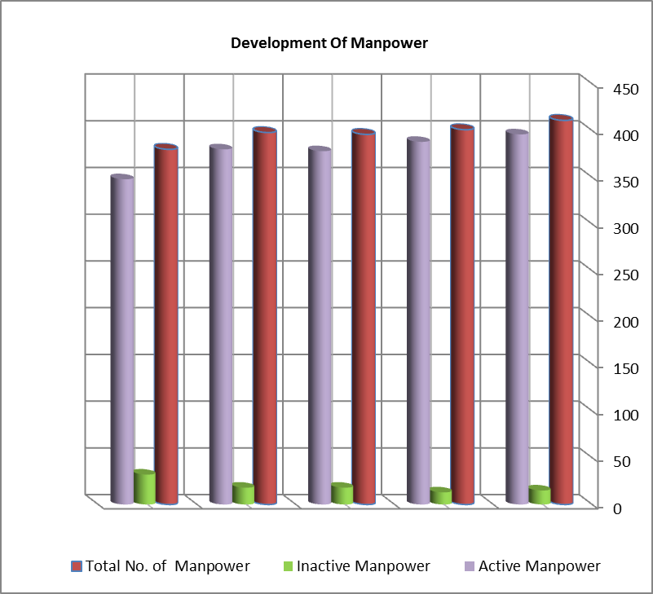
2019 2018 2017 2016 2015
32
18
18
13
15
411
396
401
388
396
378
398
380
380
348
- Training and Development:
113 of the employees have been participated in training programs held by Iraqi Accounting and Financial Training Center. The following table indicates the development of training in the last five years and the rate of trainees' number to the total number of manpower in the company …

Table No. ( 2 )
Training & development for the last five years

Rate  of  Change | Rate of Trainees to the Total | No.  of  Trainees | Total  No. of  Manpower | Year
- | 29% | 120 | 411 | 2015
-4% | 29% | 115 | 401 | 2016
35% | 39% | 155 | 396 | 2017
-18% | 32% | 127 | 398 | 2018
-11% | 30% | 113 | 380 | 2019

Secondly: General Indicators of the Company Performance:
- Achievement of Objectives:
The company participates in developing Economics through providing insurance protection to the customers, encouraging them to save money which used in investment.
- Insurance Premiums:
The company deals with all types of insurance, life and non-life insurance. The following table indicates the development of planned and earned premiums and the rates of implementation for the last five years.
Table No. ( 3 )
Development of planned and earned premiums

Rate of Implement. | Rate of Change % | Earned Premiums | Rate of Change % | Planned Premiums | Year
106% | - | 63468048000 | - | 60000000000 | 2015
89% | -16% | 53178322000 | 0 | 60000000000 | 2016
82% | -7% | 49459329000 | 0 | 60000000000 | 2017
156% | 64% | 81146644000 | -13% | 52000000000 | 2018
115% | -12% | 71339704000 | 19% | 62000000000 | 2019

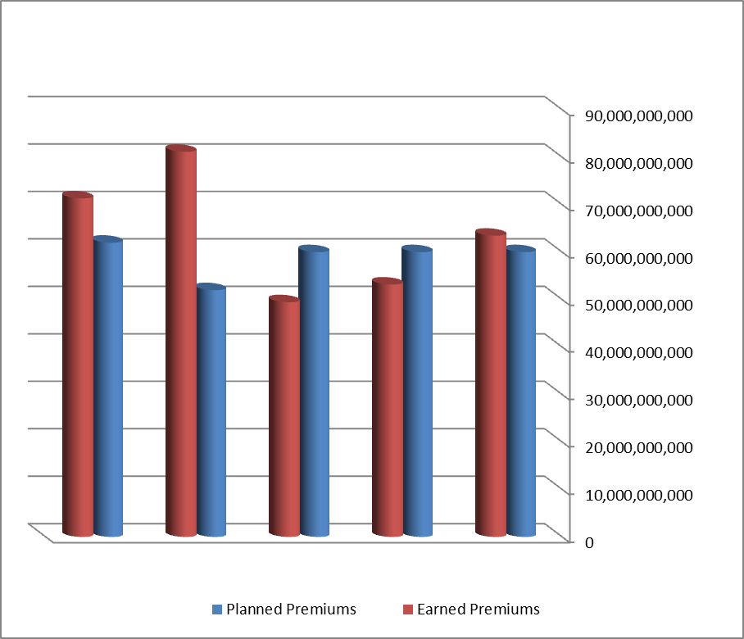
2019 2018 2017 2016 2015
Development of Planned and Earned Premiums
Investment Revenues:
The revenues earned from investing the surplus. The following table indicates the development of planned and earned investment revenues and the rates of implementation for the last five years.

Table No. ( 4 )
Development of planned and earned investment revenues

Rate of Implement.  % | Rate of Change  % | Earned Investment Revenues | Rate of Change  % | Planned Investment Revenues | Year
105% | - | 2771112000 | - | 2650000000 | 2015
103% | 1% | 2796636000 | 3% | 2725000000 | 2016
107% | 5% | 2923242000 | 0% | 2725000000 | 2017
107% | 2% | 2993785000 | 3% | 2795000000 | 2018
111% | 11% | 3320460000 | 7% | 3000000000 | 2019

- Technical Reserves:

Table No. (5)
Development of technical reserves for (2015-2019)

Rate  of Change | Rate of Confined to Planned Reserves | Confined Reserves | Amounts of Planned Reserves | Year
- | 97% | 30174355000 | 31000000000 | 2015
-6% | 77% | 28319934000 | 37000000000 | 2016
11% | 75% | 31321205000 | 42000000000 | 2017
32% | 92% | 41404960000 | 45000000000 | 2018
7% | 87% | 44407298000 | 51000000000 | 2019

Table No. (6)
Types of technical reserves compared to 2018

Rate  of Change | Reserved Amounts in 2018 | Reserved Amounts in 2019 | Type  of Reserves
-19% | 9618964000 | 7806616000 | Reserves of Effected Risks
48% | 5570237000 | 8223229000 | Reserves of Outstanding Claims
9% | 12825000000 | 14000000000 | Reserves of Emergency
7% | 13390759000 | 14377453000 | Accounting Reserves

Table No. (7)
Capital compared to Reserves for 2015 to 2019

Rate of Reserves to Capital | Accumulated Losses | Confined Profits | Non-Technical Reserves | Capital | Year
597% | 0 | 0 | 11949186000 | 2000000000 | 2015
649% | 0 | 0 | 12974048000 | 2000000000 | 2016
704% | 0 | 0 | 14081416000 | 2000000000 | 2017
792% | 0 | 0 | 15853561000 | 2000000000 | 2018
896% | 0 | 0 | 17911754000 | 2000000000 | 2019

- Scope of Implementation of the Plan

- Insurance Premiums according to Portfolios:
The company distributes its plan according to marketing insurance portfolios. The following table indicates the development of planned and earned premiums for each insurance portfolio, with a comparison between planned and earned premiums for each one.
Table No. ( 8 )
Planned & earned premiums according to portfolios in 2019

Rate of Change  % | Earned Premiums in 2018 | Rate of Implement.  % | Earned Premiums | Planned Premiums | Portfolio
12% | 4747338000 | 107% | 5335667000 | 5000000000 | Individual Life Ins.
-21% | 64680931000 | 114% | 51376472000 | 45000000000 | Group Ins.
-67% | 3003040000 | 28% | 979482000 | 3500000000 | Motor Ins.
35% | 32883000 | 30% | 44265000 | 150000000 | Marine-Cargo Ins.
15% | 2495798000 | 96% | 2865291000 | 3000000000 | Fire Ins.
105% | 346409000 | 203% | 711027000 | 350000000 | Engineering Ins.
76% | 5066339000 | 223% | 8916488000 | 4000000000 | Public Accidents Ins.

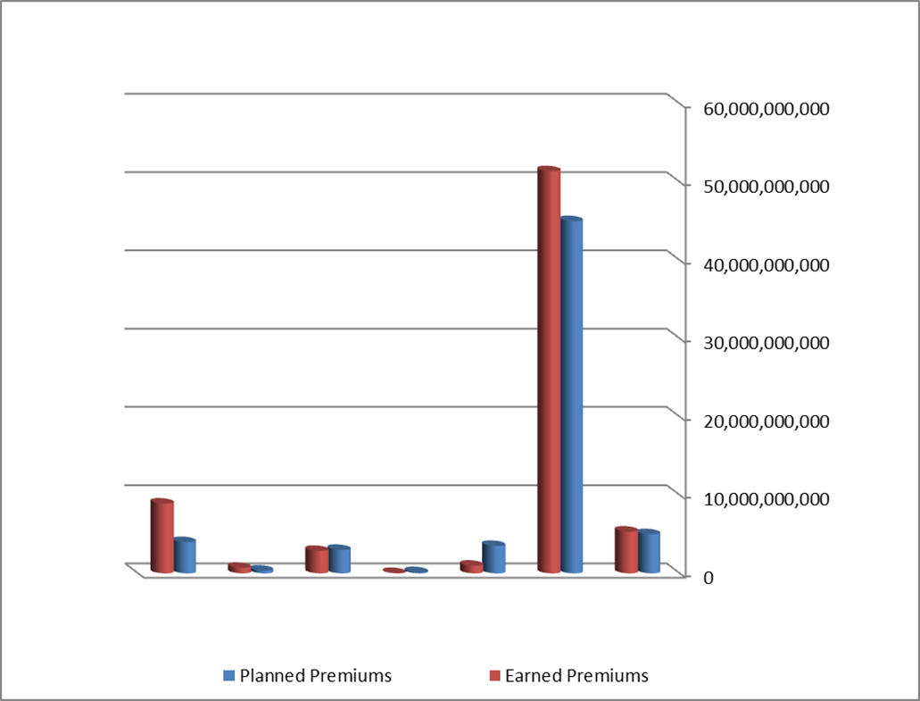
Public Accidents Ins.
Engineering Ins.
Fire Ins.
Marine-Cargo Ins.
Motor Ins.
Group Ins.
Individual Life Ass.
Planned & Earned Premiums According to Portfolios in 2019
- Individual Life Insurance:

The individual life Insurance distinguished from other types of insurance that it offers saving and protection services. The company has an annual plan to follow up the marketer activities in addition to the mentioned premiums plan. The two following tables indicate the development of the number and insurance amounts of the new individual life Insurance policies for (2015-2019).

Table No. (9)
Development of planned and earned individual life insurance policies

Rate of Change | Rate of Implement. | Earned Policies No. | Planned Policies No. | Year
- | 337% | 4044 | 1200 | 2015
5% | 355% | 4255 | 1200 | 2016
-23% | 272% | 3261 | 1200 | 2017
10% | 144% | 3597 | 2500 | 2018
-11% | 107% | 3196 | 3000 | 2019

The earned policies number: are the issued policies number deducted the cancelled policies number.
Table No. (10)
Development of planned and earned individual life insurance amounts

Rate of Change | Rate of Implement. | Earned Ins. Amounts | Planned Ins. Amounts | Year
- | 189% | 14199206000 | 7500000000 | 2015
-8% | 175% | 13117275000 | 7500000000 | 2016
-30% | 115% | 9186050000 | 8000000000 | 2017
-2% | 112% | 8984354000 | 8000000000 | 2018
16% | 130% | 10426877000 | 8000000000 | 2019

The earned Ins. amounts: are the insurance amounts of the issued policies deducted the cancelled ones.
- Types of Investment Revenues:
There are four types of the investment of the surplus:-
- Real Estate Investment.
- Contribution in the private and mixed sectors companies.
- Real Estate Loans.
- Deposit at Banks.
The invested amounts volume amounted to IQD. 63101000000/- which is more than the invested amounts in 2018 by 16%.
The following table indicates the development of the earned and planned investment revenues and rate of investment revenue to the invested amount in the last five years.
Table No. (11)
Development of investment amounts compared with returns
Rate of Revenue to Invested Amount | Earned Investment Revenues | Rate  of Change | Rate of Implement. | Earned Investment Amounts | Planned Investment Amounts | Year
8% | 2771112000 | - | 80% | 34426935000 | 43000000000 | 2015
7% | 2796636000 | 6% | 84% | 36513979000 | 43500000000 | 2016
7% | 2923242000 | 8% | 90% | 39408445000 | 43500000000 | 2017
6% | 2993785000 | 38% | 122% | 54330705000 | 44500000000 | 2018
5% | 3320460000 | 16% | 95% | 63100834000 | 66100000000 | 2019

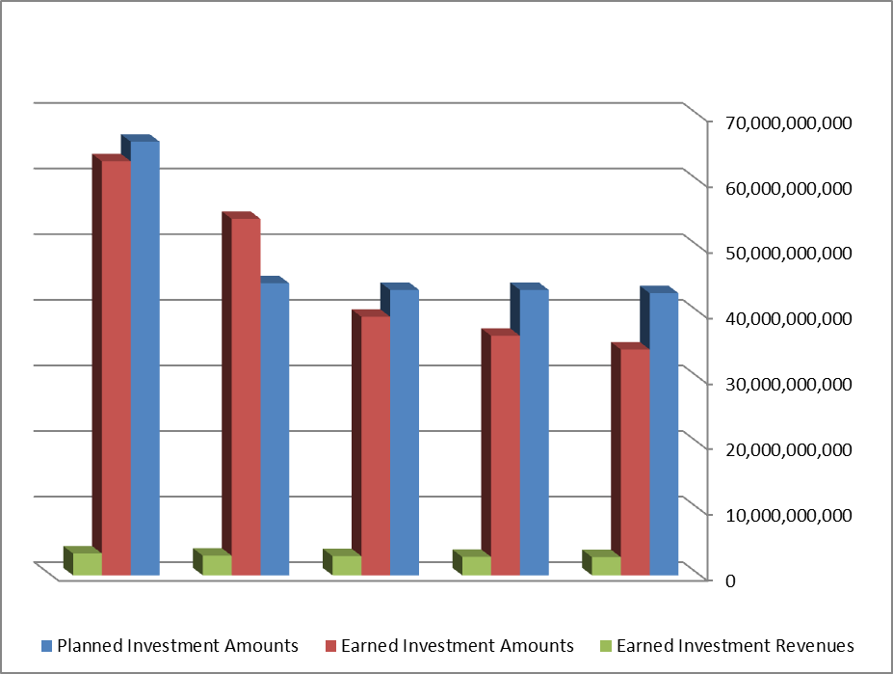
2019 2018 2017 2016 2015
Development of Investment Amounts Compared with Returns

The following table states the investment amounts according to investment type and their development for the last five years.

Table No. (12)
Investment amounts according to the types

Investment Type |  |  |  | Year
Deposits | Loans | Shares | Real Estate | Year
20360085000 | 3043350000 | 6189931000 | 4833568000 | 2015
22100000000 | 2572814000 | 6320643000 | 5520522000 | 2016
25100000000 | 2308931000 | 6478992000 | 5520522000 | 2017
39700000000 | 2578677000 | 6478992000 | 5573036000 | 2018
47700000000 | 2191306000 | 7636492000 | 5573036000 | 2019

The following table indicates the planned and earned investment revenues in 2019 compared with 2018.

Table No. (13)
Planned and Earned Investment Revenues in 2019

Rate  of Change | Earned Revenues in 2018 | Rate of Implement. | Rate to Total | Earned Revenues | Planned Revenues | Type of Investment
5% | 1285631000 | 77% | 41% | 1345156000 | 1750000000 | Real Estate Investment
43% | 952697000 | 209% | 41% | 1358340000 | 650000000 | Fixed Deposits
14% | 96465000 | 180% | 3% | 110046000 | 61000000 | Real Estate  Loans
-23% | 658992000 | 94% | 15% | 506918000 | 539000000 | Contribution in private and mixed sector companies
11% | 2993785000 | 111% | 100% | 3320460000 | 3000000000 | Total

The following table indicates the names of private and mixed companies which our company shares in their capital more than 10% of our company capital with the contribution amounts for each.

Table No. (14)
Names of mixed & private companies

Our Company Rep. | Close Price | Contr-ibution Rate | Contribution Amount | Sector | Company  Name
None | 0.310 | 2.59% | 436002855 | Mixed | Light Industries Co. | 1
None | 1.250 | 3.15% | 290321236 | Mixed | Modern Paint Industries Co. | 2
None | 0.470 | 3.89% | 209260746 | Mixed | Modern Construction Co. | 3
Haifaa Essa Shamoun | 5.800 | 5% | 682500000 | Mixed | Iraqi Co. Seeds Production | 4
None | 3.290 | 1% | 1866170880 | Private | Baghdad Soft Drinks Co. | 5
None | Not inserted | 7% | 210000000 | Mixed | Baghdad Al-Salam Co. for Food Industries | 6
None | 0.270 | 0.23% | 579013845 | Private | Investment Bank of Iraq | 7
None | Not inserted | 1% | 1000000000 | Mixed | Iraqi Deposit Insurance Company | 8
None | Not inserted | 2.62% | 3123493 | Outside Iraq | Bahrain National Holding Co. | 9
None | Not inserted | 1% | 756437 | Outside Iraq | Arab Reinsurance Co. | 10

Thirdly: Financial Indicators of the Company

- Analysis of the Company Profitability:
The distributable surplus amount of operating processes rises to 9946296000/- IQD as on 31/12/2019 which is more than the planned profit by (127%) and more than the achieved profit of 2018 by 12%.

Table No. (15)
Development of planned and earned profits

Rate of Change | Rate of Implement. | Net Earned Profit | Net Planned Profit | Year
- | 153% | 3393680000 | 2222500000 | 2015
121% | 416% | 7499389000 | 1801270000 | 2016
-22% | 138% | 5831215000 | 4234000000 | 2017
52% | 214% | 8851569000 | 4139990000 | 2018
12% | 127% | 9946296000 | 7828643000 | 2019

- Noting that there are no confined profits for 2019 and the previous years.

- Expenses:
The company's expenses are divided into two main types:-
- Ins. Operating Expenses:

- Claims:
Claims paid to policyholders and beneficiaries which form the bulk of the expenses. The two following tables indicate the development of paid and expected claims & the rate of paid claims to earned premiums for each insurance portfolio.
Table No. (16)
Development of expected and paid claims for (2015-2019)

Rate of Change in Paid Claims | Rate of Paid to Expected Claims | Paid  Claims | Expected Claims | Year
- | 131% | 35309789000 | 27000000000 | 2015
-13% | 96% | 30684224000 | 32000000000 | 2016
-14% | 83% | 26526525000 | 32000000000 | 2017
29% | 107% | 34242735000 | 32000000000 | 2018
8% | 106% | 37030649000 | 35000000000 | 2019

Table No. (17)

Paid claims compared to earned premiums portfolios in 2019

Rate of Claims to Premiums | Paid  Claims | Earned Premiums | Portfolio
113% | 6048237000 | 5335667000 | Individual Life Ins.
59% | 30264553000 | 51376472000 | Group Ins.
2% | 20914000 | 979482000 | Motor Ins.
0% | 0 | 44265000 | Marine-Cargo Ins.
3% | 238103000 | 8916488000 | Public Accidents Ins.
16% | 448856000 | 2865291000 | Fire Ins.
1% | 7766000 | 711027000 | Engineering Ins.
0.1% | 2220000 | 1111012000 | Reins. Revenues
52% | 37030649000 | 71339704000 | Total

- Issued Reinsurance Premiums:

The reinsurance premiums reached to IQD 2880000000/- in 2019 which represents 4% of the total premiums and down (41%) compared with 2018. Noting that the bulk of the issued reinsurance premiums belong to non-life insurance business while the company retains the entire of the sum insured of life insurance policies. The following table indicates the development of issued reinsurance premiums for the last five years.

Table No. (18)
Development of issued reinsurance premiums compared with total earned premiums

Rate  of  Change | Rate of Reins. Premiums to Earned Premiums | Issued Reinsurance Premiums | Earned Premiums | Year
- | 8% | 5365002000 | 63468048000 | 2015
-19% | 8% | 4345745000 | 53178322000 | 2016
-19% | 7% | 3509281000 | 49459329000 | 2017
40% | 6% | 4905276000 | 81146644000 | 2018
-41% | 4% | 2880214000 | 71339704000 | 2019

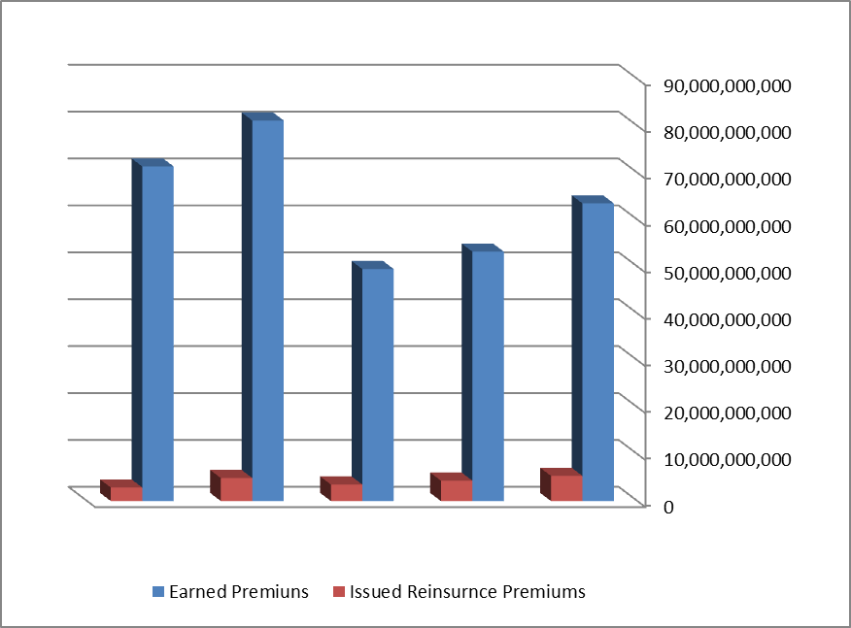
2019 2018 2017 2016 2015
Development of Issued Reinsurance Premiums Compared with total Earned Premiums

- Issued Reinsurance Claims:

The issued reinsurance claims reached to IQD. 227115000/- in 2019 which represents 1% of the total claims.
Table No. (19)
Development of issued reinsurance share in claims compared with total paid claims

Rate of Change | Rate of Reins. Share in Paid Claims | Reinsurance Share | Paid Claims | Year
- | 1% | 512876000 | 35309789000 | 2015
144% | 4% | 1249206000 | 30684224000 | 2016
-42% | 3% | 725463000 | 26526525000 | 2017
-46% | 1% | 388525000 | 34242735000 | 2018
42% | 1% | 227115000 | 37030649000 | 2019

Productivity
1- Employee Productivity
The following table indicates the development of the employee productivity for the last five years.
Table No. (20)
Development of employee productivity for (2015-2019)

Employee Productivity | Employees  No. | Earned  Premiums | Year
154423474 | 411 | 63468048000 | 2015
132614268 | 401 | 53178322000 | 2016
124897295 | 396 | 49459329000 | 2017
203886040 | 398 | 81146644000 | 2018
187736063 | 380 | 71339704000 | 2019

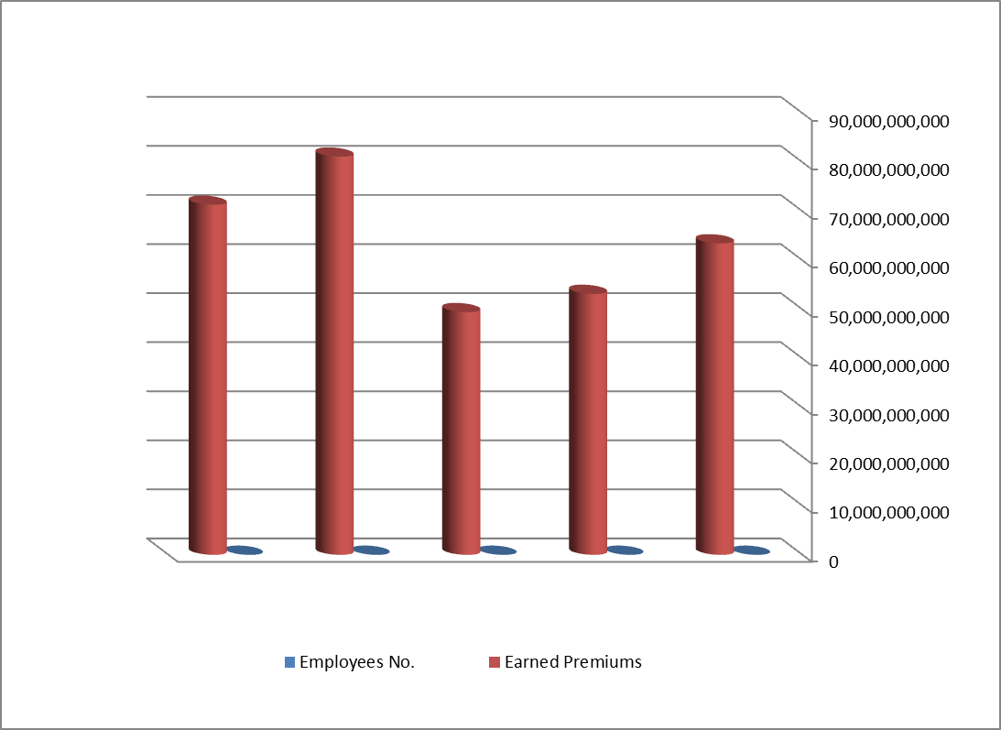
2019 2018 2017 2016 2015
Development of Employee Productivity for (2015-2019)

2- Fee Productivity
The following table indicates the development of the fee productivity for the last five years.

Table No. (21)
Development of fee productivity for (2015-2019)

Fee  Productivity | Paid Salaries & Fees | Earned  Premiums | Year
13,109 | 4841414000 | 63468048000 | 2015
12,193 | 4361336000 | 53178322000 | 2016
11,621 | 4256152000 | 49459329000 | 2017
18,276 | 4440185000 | 81146644000 | 2018
14,915 | 4783104000 | 71339704000 | 2019

2019 2018 2017 2016 2015
Development of Fee Productivity for (2015-2019)

Administrative Expenses:

- Total Numbers:
The administrative expenses include salaries, fees, requirements of goods, services and other expenses. The planned administrative expenses for 2019 reached to IQD 8271000000/- whereas the paid administrative expenses reached to IQD 7063000000/- which represents 85% (Rate of implementation). The following table indicates the development of the planned and paid administrative expenses for the last five years.

Table No. (22)
Development of planned & paid administrative expenses

Rate  of  Implement. | Rate  of  Change | Paid Administrative Expenses | Rate  of  Change | Planned Administrative Expenses | Year
69% | - | 5864049000 | - | 8477500000 | 2015
59% | -0.3% | 5841568000 | 18% | 9973730000 | 2016
71% | -7% | 5434268000 | -23% | 7680811000 | 2017
96% | 37% | 7431384000 | 1% | 7755010000 | 2018
85% | -5% | 7063302000 | 7% | 8271357000 | 2019

- Advertisement:
Table No (23)
Development of Advertisement Amounts for 2015 – 2019

Year | Planned Amounts | Paid  Amounts | Rate  of  Implement. | Rate  of Change
2015 | 100000000 | 49349000 | 49% | -
2016 | 100000000 | 65297000 | 65% | 32%
2017 | 90000000 | 83605000 | 93% | 28%
2018 | 90000000 | 54836000 | 61% | -34%
2019 | 200000000 | 156687000 | 78% | 186%

- Hospitality:
Table No (24)
Development of Hospitality Amounts for 2015 – 2019

Year | Planned Amounts | Paid  Amounts | Rate  of  Implement. | Rate  of Change
2015 | 15000000 | 8814000 | 59% | -
2016 | 15000000 | 6986000 | 47% | -21%
2017 | 10000000 | 8624000 | 86% | 23%
2018 | 10000000 | 8190000 | 82% | -5%
2019 | 15000000 | 8094000 | 54% | -1%

- Travel:
Table No (25)
Development of Travel Amounts for 2015 – 2019

Year | Planned Amounts | Paid  Amounts | Rate  of  Implement. | Rate  of Change
2015 | 115000000 | 81329000 | 71% | -
2016 | 125000000 | 79434000 | 64% | -2%
2017 | 120000000 | 105869000 | 88% | 33%
2018 | 115000000 | 90831000 | 79% | -14%
2019 | 130000000 | 82588000 | 64% | -9%

- Research & Development:

Table No (26)
Development of Research & Development Amounts for 2015 – 2019

Year | Planned Amounts | Paid  Amounts | Rate of  Implement. | Rate  of Change
2015 | 237558000 | 38995000 | 16% | -
2016 | 126089000 | 45591000 | 36% | 121%
2017 | 290093000 | 58246000 | 20% | 28%
2018 | 619610000 | 56511000 | 9% | -3%
2019 | 695838000 | 68193000 | 10% | 21%

- Effect of Activity on Balance of Payment:
The following table states summary of the outgoing and incoming amounts.

Table No. (27)
Effect of Activity on Balance of Payment for 2015 – 2019
Figures are in USD
Effect of Activity on Balance of Payment | Outgoing  Amounts | Incoming  Amounts | Year
51653 | 5750 | 57403 | 2015
99995 | 258398 | 358393 | 2016
107390 | 171572 | 278926 | 2017
162316 | 5450 | 167766 | 2018
1194204 | 1279490 | 85286 | 2019

- Effect of Inflation on Activity:
The change in the general level of prices, the rise in inflation rates, the change in the structure of the Iraqi economy, in addition to the instability of the security situation over the past two decades, had a clear role in the significant decline in the value of the life insurance policy and the diminution of its profits, as this policy differs from the rest of the policies because the period of insurance is long and it is a saving policy, whose premium consists of two parts, the first is the risk premium and the second is the saving premium, which is greatly affected by the reasons mentioned above. Despite the measures taken by the company to develop its investments, the investments, in turn, were faltering due to their reliance on interest collected from government banks on fixed deposits, at a rate of 76% of the total investments for 2019. As for non-life insurance, reducing the impact of inflation is through the fast completion of claims during the insurance year.
Fourthly: Solvency
The solvency of the company reached to 255% in 2019 which indicates the progress and improvement of the company. The following table indicates the development of the solvency for the last five years.

Table No. (28)
Development of Solvency

Rate  of Change | Acceptable  Solvency | Required Solvency | Current Solvency | Year
- | 168% | 11265076000 | 18973604000 | 2015
32% | 222% | 9552848000 | 21194051000 | 2016
18% | 261% | 8336529000 | 21776416000 | 2017
-21% | 206% | 14921310000 | 30678561000 | 2018
24% | 255% | 13287067000 | 33911754000 | 2019

MINISTRY OF FINANCE
IRAQ INSURANCE COMPANY
BALANCE SHEET AS ON Dec 31, 2019

Currency Iraqi Dinars IQD
Rate US $ 1 = 1166 IQD
Figures in 1000 IQD

Assets | Figures in 1000 IQD.  2019 | Figures in 1000 IQD.  2018 | Rate of Change
Money | 21129634 | 30429564 | -31%
Investments | 55159239 | 47689333 | 16%
Debtors | 8876666 | 8483297 | 5%
Fixed Assets | 28501 | 28501 | 0
Total | 85194040 | 86630695 | -2%

Liabilities | Figures in 1000 IQD.  2019 | Figures in 1000 IQD.  2018 |  | Rate of Change
Current Liabilities
Creditors | 20874988 | 27372174 |  | -24%
Fixed Liabilities
Paid Capital | 2000000 | 2000000 |  | 0
Reserves | 17911754 | 15853561 |  | 13%
Technical Reserves | 44407298 | 41404960 |  | 7%
Total | 85194040 | 86630695 | -2%

MINISTRY OF FINANCE
IRAQ INSURANCE COMPANY
Profits and Losses Account & Distribution for Financial year on Dec 31, 2019

Operating Activity Revenues | Figures in 1000 IQD.  2019 | Figures in 1000 IQD.  2018 | Rate of Change
Ins. Processes Revenues | 72364516 | 82821784 | -13%
Investment Revenues | 3320460 | 2993785 | 11%

Operating Activity Expenses | Figures in 1000 IQD.  2019 | Figures in 1000 IQD.  2018 | Rate of Change
Ins. Processes Expenses | 58795664 | 69178971 | -15%
Depreciation | 345704 | 344875 | 0.2%
Administrative Expenses | 569607 | 5248733 | 9%

 | Figures in 1000 IQD.  2019 | Figures in 1000 IQD.  2018 | Rate of Change
Operating Processes Surplus | 10848000 | 11042990 | 2%
Transfer & Other Revenues | 566458 | 80640 | 602%

Transfer & Other Expenses | Figures in 1000 IQD.  2019 | Figures in 1000 IQD.  2018 | Rate of Change
Transfer Expenses | 1126281 | 2129027 | -47%
Other Expenses | 240414 | 53624 | 348%
Social Allocations (1%) Social Protection | 100468 | 89410 | 12%

Surplus is distributed under the law as follows: | Figures in 1000 IQD.  2019 | Figures in 1000 IQD.  2018 | Rate of Change
45% Public Treasury Share | 4475833 | 3983206 | 12%
33% Employees Share | 3280377 | 2921003 | 12%
7% Development & Research Share | 695838 | 619610 | 12%
5% Social Services Share | 497027 | 442578 | 12%
General Reserve | 997221 | 885172 | 12%
Surplus | 9946296 | 8851569 | 12%

Capital gains and any other profits resulting from unusual activity are excluded from the employees’ share amounting IQD 5759784, based on Second Paragraph of Article 11 - Chapter Three / Profits and Losses of the Public Companies Act No. (22) of 1997 (amended).

